**Table Creation :**

CREATE TABLE PUBLISHER

(NAME VARCHAR2 (20) PRIMARY KEY,

PHONE INTEGER,

ADDRESS VARCHAR2 (20));

CREATE TABLE BOOK(BOOK_ID INTEGER PRIMARY KEY,

TITLE VARCHAR2 (20),

PUB_YEAR VARCHAR2 (20),

PUBLISHER_NAME REFERENCES PUBLISHER (NAME) ON DELETE CASCADE);

CREATE TABLE BOOK_AUTHORS

(AUTHOR_NAME VARCHAR2 (20),

BOOK_ID REFERENCES BOOK (BOOK_ID) ON DELETE CASCADE,

PRIMARY KEY (BOOK_ID, AUTHOR_NAME));

CREATE TABLE LIBRARY_BRANCH

(BRANCH_ID INTEGER PRIMARY KEY,

BRANCH_NAME VARCHAR2 (50),

ADDRESS VARCHAR2 (50));

CREATE TABLE BOOK_COPIES

(NO_OF_COPIES INTEGER,BOOK_ID REFERENCES BOOK (BOOK_ID) ON DELETE CASCADE,

BRANCH_ID REFERENCES LIBRARY_BRANCH (BRANCH_ID) ON DELETE CASCADE,

PRIMARY KEY (BOOK_ID, BRANCH_ID));

CREATE TABLE CARD

(CARD_NO INTEGER PRIMARY KEY);

CREATE TABLE BOOK_LENDING

(DATE_OUT DATE,DUE_DATE DATE,BOOK_ID REFERENCES BOOK (BOOK_ID) ON DELETE CASCADE,

BRANCH_ID REFERENCES LIBRARY_BRANCH (BRANCH_ID) ON DELETE CASCADE,

CARD_NO REFERENCES CARD (CARD_NO) ON DELETE CASCADE,

PRIMARY KEY (BOOK_ID, BRANCH_ID, CARD_NO)

**Insertion of Values to Tables :**

INSERT INTO PUBLISHER VALUES ( ̳MCGRAW-HILL‘, 9989076587, ̳BANGALORE‘);

INSERT INTO PUBLISHER VALUES ( ̳PEARSON‘, 9889076565, ̳NEWDELHI‘);

INSERT INTO PUBLISHER VALUES ( ̳RANDOM HOUSE‘, 7455679345, ̳HYDRABAD‘);

INSERT INTO PUBLISHER VALUES ( ̳HACHETTE LIVRE‘, 8970862340, ̳CHENAI‘);

INSERT INTO PUBLISHER VALUES ( ̳GRUPO PLANETA‘, 7756120238, ̳BANGALORE‘);

INSERT INTO BOOK VALUES (1,‘DBMS‘,‘JAN-2017‘, ̳MCGRAW-HILL‘);

INSERT INTO BOOK VALUES (2,‘ADBMS‘,‘JUN-2016‘, ̳MCGRAW-HILL‘);

INSERT INTO BOOK VALUES (3,‘CN‘,‘SEP-2016‘, ̳PEARSON‘);

INSERT INTO BOOK VALUES (4,‘CG‘,‘SEP-2015‘, ̳GRUPO PLANETA‘);

INSERT INTO BOOK VALUES (5,‘OS‘,‘MAY-2016‘, ̳PEARSON‘);

INSERT INTO BOOK_AUTHORS VALUES (‘NAVATHE‘, 1);

INSERT INTO BOOK_AUTHORS VALUES (‘NAVATHE‘, 2);

INSERT INTO BOOK_AUTHORS VALUES (‘TANENBAUM‘, 3);

INSERT INTO BOOK_AUTHORS VALUES (‘EDWARD ANGEL‘, 4);

INSERT INTO BOOK_AUTHORS VALUES (‘GALVIN‘, 5);

INSERT INTO LIBRARY_BRANCH VALUES (10,‘RR NAGAR‘,‘BANGALORE‘);

INSERT INTO LIBRARY_BRANCH VALUES (11,‘RNSIT‘,‘BANGALORE‘);

INSERT INTO LIBRARY_BRANCH VALUES (12,‘RAJAJI NAGAR‘, ‘BANGALORE‘);

INSERT INTO LIBRARY_BRANCH VALUES (13,‘NITTE‘,‘MANGALORE‘);

INSERT INTO LIBRARY_BRANCH VALUES (14,‘MANIPAL‘,‘UDUPI‘);

INSERT INTO BOOK_COPIES VALUES (10, 1, 10);

INSERT INTO BOOK_COPIES VALUES (5, 1, 11);

INSERT INTO BOOK_COPIES VALUES (2, 2, 12);

INSERT INTO BOOK_COPIES VALUES (5, 2, 13);

INSERT INTO BOOK_COPIES VALUES (7, 3, 14);

INSERT INTO BOOK_COPIES VALUES (1, 5, 10);

INSERT INTO BOOK_COPIES VALUES (3, 4, 11);

INSERT INTO CARD VALUES (100);

INSERT INTO CARD VALUES (101);

INSERT INTO CARD VALUES (102);

INSERT INTO CARD VALUES (103);

INSERT INTO CARD VALUES (104);

INSERT INTO BOOK_LENDING VALUES (‘01-JAN-17‘,‘01-JUN-17‘, 1, 10, 101);

INSERT INTO BOOK_LENDING VALUES (‘11-JAN-17‘,‘11-MAR-17‘, 3, 14, 101);

INSERT INTO BOOK_LENDING VALUES (‘21-FEB-17‘,‘21-APR-17‘, 2, 13, 101);

INSERT INTOBOOK_LENDING VALUES (‘15-MAR-17‘,‘15-JUL-17‘, 4, 11, 101);

INSERT INTO BOOK_LENDING VALUES ( ̳12-APR-17‘,‘12-MAY-17‘, 1, 11, 104);

**Queries:**

1. **Retrieve details of all books in the library –id, title, name of publisher, authors, number of copies in each branch, etc.**

SELECT B.BOOK_ID, B.TITLE, B.PUBLISHER_NAME, A.AUTHOR_NAME, C.NO_OF_COPIES, L.BRANCH_ID

FROM BOOK B, BOOK_AUTHORS A, BOOK_COPIES C, LIBRARY_BRANCH L

WHERE B.BOOK_ID=A.BOOK_ID

AND B.BOOK_ID=C.BOOK_ID

AND L.BRANCH_ID=C.BRANCH_ID;

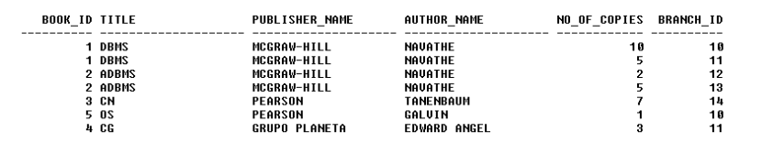

1. **Get the particulars of borrowers who have borrowed more than 3 books,but from Jan 2017 to Jun 2017.**

SELECT CARD_NO

FROM BOOK_LENDING

WHERE DATE_OUT BETWEEN ‘01-JAN-2017‘ AND ‘01-JUL-2017‘

GROUP BY CARD_NO

HAVING COUNT (*)>3;



1. **Delete a book in BOOK table. Update the contents of other tables to reflect this data manipulation operation.**

DELETE FROM BOOK

WHERE BOOK_ID=3;

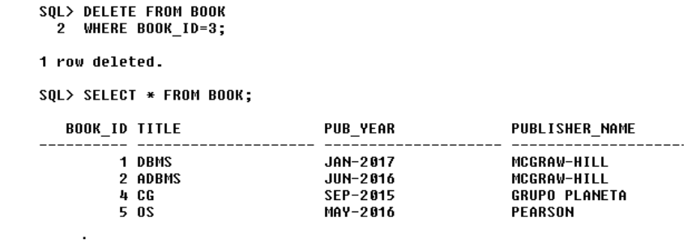

1. **list the publisher of book with author “ABC” and “PQR”**.

SELECT PUBLISHER_NAME

FROM BOOK,

BOOK_AUTHORS

WHERE

AUTHOR_NAME=’PQR’ AND

AUTHOR_NAME=’ABC’